1. Explain what the simple List component does.

The List component is a commonly used UI (User Interface) element in both web and mobile applications that presents a collection of items in a scrollable list format, either vertically or horizontally. This component is versatile and can display various types of content, including text, images, videos, links, and more. Each item in the list generally includes a brief summary or preview of the content, accompanied by an optional thumbnail or icon. Users can interact with the List component by scrolling through the items, selecting an item to view additional information or perform an action, or using search or filtering functionality to narrow down the list. To provide a dynamic and engaging user experience, the List component is frequently used in conjunction with other UI elements like buttons, forms, and navigation menus.

There are three main types of list components in React:

**Unordered List (<ul>):** This type of list component is used to create an unordered list of items. Each item is typically rendered as an <li> element.

**Ordered List (<ol>):** This type of list component is used to create a numbered list of items. Each item is typically rendered as an <li> element.

**Definition List (<dl>):** This type of list component is used to create a list of terms and their definitions. Each term is typically rendered as a <dt> element and each definition is typically rendered as a <dd> element.

In addition to these three main types, there are many other variations of list components that you can create in React, such as nested lists, horizontal lists, grid-based lists, and more.

Here are some example of list and their screenshot

//UnorderedList

import React from 'react';

import './list.css';

const list = ({ items }) => {

return (

<ul className="list">

{items.map((item) => (

<li key={item.id} className="list-item">

<h3>{item.name}</h3>

{item.description && <p>{item.description}</p>}

{item.image && <img src={item.image} alt={item.name} className="list-item-image" />}

</li>

))}

</ul>

);

};

export default list;

OUTPUT :- 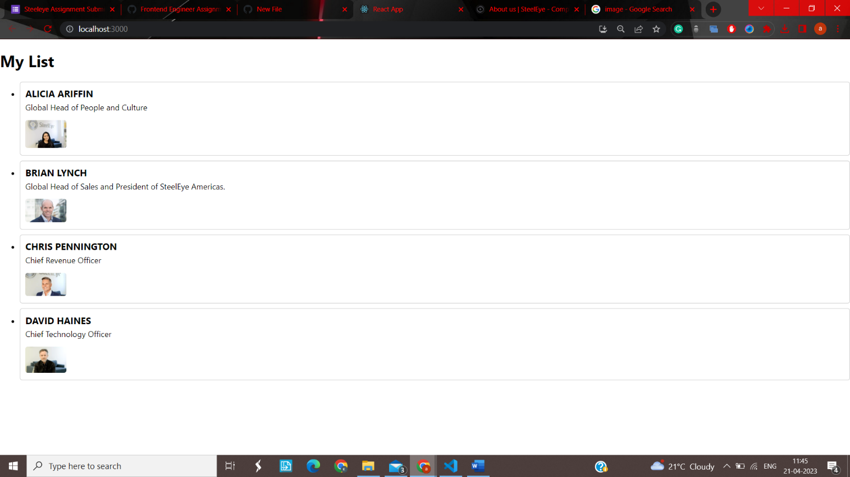

//OrderedList

import React from 'react';

import './list.css';

const list = ({ items }) => {

return (

<ol className="list">

{items.map((item) => (

<li key={item.id} className="list-item">

<h3>{item.name}</h3>

{item.description && <p>{item.description}</p>}

{item.image && <img src={item.image} alt={item.name} className="list-item-image" />}

</li>

))}

</ol>

);

};

export default list;

OUTPUT :- 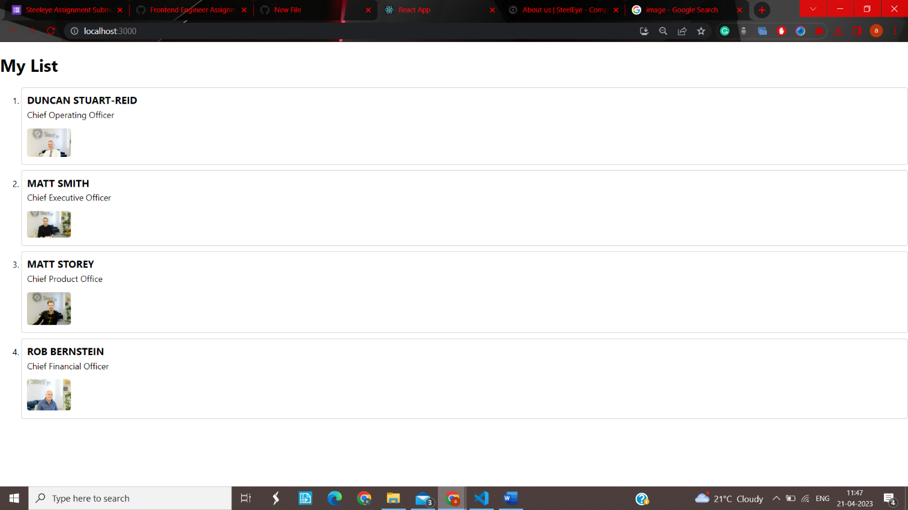

// DefinitionList

import React from 'react';

import './list.css';

const DefinitionList = ({ items }) => {

return (

<dl className="definition-list">

{items.map((item) => (

<React.Fragment key={item.term}>

<dt>{item.term}</dt>

<dd>{item.description}</dd>

</React.Fragment>

))}

</dl>

);

};

export default DefinitionList;

OUTPUT :- 